Project Report

|  |  |
| --- | --- |
| Project Title | Problem Manage a Server Outage Scenario & an Issue & Change Request Management System |
| Qualification Name (NICF) | Advanced Certificate in Software Applications (Development and Deployment) |
| Product Name |  |
| Module Name (NICF) |  |

|  |  |  |  |
| --- | --- | --- | --- |
| Student name | | Assessor name | |
| Mohammad Reihan Zakya Alawi | |  | |
| Date issued | Completion date | | Submitted on |
|  |  | |  |
|  | |  | |
| Project title | Student Registration Form Development | | |

|  |
| --- |
| Learner declaration |
| I certify that the work submitted for this assignment is my own and research sources are fully acknowledged.  Student signature: Date: August 2023 |

Table of Contents

1. Project Background 2

2. Project Objective 3

3. Project Requirements Specifications 4

3.1 Functional requirements 4

3.2 Non-functional requirements 4

4. Task 1: Principles of Problem Management 5

4.1 What is Problem Management? 5

4.2 The Three Phases of Problem Management 5

4.3 Principles of Problem Management 5

4.4 Problem Management Example 5

5. Task 2: Tools, Process & Technologies 7

1. Problem Logging 7

6. Task 3: Investigate & Diagnose 8

7. Task 4: Explain Prioritize 8

8. Task 5: Problem Management Solution 9

9. Task 7: Best Practices in Problem Management 10

# Project Background

Developing a Software Developer's Community Portal

ABC Jobs Pte Ltd is embarking on a transformative project to establish a dedicated community portal for software developers akin to LinkedIn. This initiative aims to create a hub where programmers and software administrators can seamlessly connect, exhibit their skills, explore job prospects, and collaborate on projects. This project aligns with the framework of the NICF-Capstone Project using Java, leveraging knowledge from previous modules, including UI Framework, Database Design, and Web Development Foundation.

The project's overarching objectives are twofold: firstly, it requires participants to design, plan, and rigorously test the community portal developed during Module 5, showcasing their ability to synthesize skills acquired throughout the course. Secondly, the project addresses the recurrent downtime experienced by ABC Jobs Pte Ltd's existing community website. By implementing problem management principles and utilizing cutting-edge tools and technologies, the project aims to resolve these issues and establish a sustainable solution. The project endeavors to enhance incident and enhancement management practices through meticulous documentation, adherence to best practices, and nurture a dynamic software developer community.

The development of this community portal underscores the intersection of technological proficiency and real-world problem-solving. It provides a tangible platform for software professionals to collaborate and flourish and exemplifies the participants' capacity to translate theoretical knowledge into practical solutions that have a lasting impact on a vital industry.

**Scope of the project**

* Explain the principles of problem management.
* Use a variety of tools, processes and techniques to identify problems.
* Conduct investigation, analysis and resolution.
* Explain the steps to investigate and diagnose problems.
* Prioritise and classify change requests.
* Prepare a solution to address the root cause of the problem.
* Document and monitor problems
* Explain best practice for documenting problems.

# Project Objective

The project objective is to effectively manage and address issues related to the community portal by implementing a problem-management framework. This involves identifying, investigating, and resolving problems to enhance the stability and performance of the website. The goal is to streamline incident and change request management, prioritize issues, propose solutions, and establish a robust problem documentation process.

**Tools & Platforms Used**

a. **IntelliJ IDEA**

* Purpose: Used as the primary integrated development environment (IDE) for developing Java-based software tools.
* Function: Provides a comprehensive platform for coding, debugging, and testing Java programs, ensuring efficient development and maintenance of the community portal.

b. **Excel Sheet**

* Purpose: Utilized for issue tracking and maintaining a known error database.
* Function: Enables the team to log and manage issues, track their status, and establish a repository of common errors, facilitating efficient troubleshooting and resolution.

c. **Microsoft Word**

* Purpose: Employed to create the Problem Management Report.
* Function: Allows the creation of detailed and structured reports that document the problem management process, including the identification, analysis, and resolution of issues related to the community portal.

d. **Diagram.net / draw.io**

* Purpose: Utilized to create visual diagrams, such as fishbone diagrams, for root cause analysis.
* Function: Enables the creation of clear and organized diagrams that help analyze the root causes of problems. Specifically, fishbone diagrams aid in identifying underlying factors contributing to issues in the community portal.

Utilizing these tools and platforms, the project aims to efficiently develop, manage, and document the problem management process, leading to an improved and more reliable community portal for software developers.

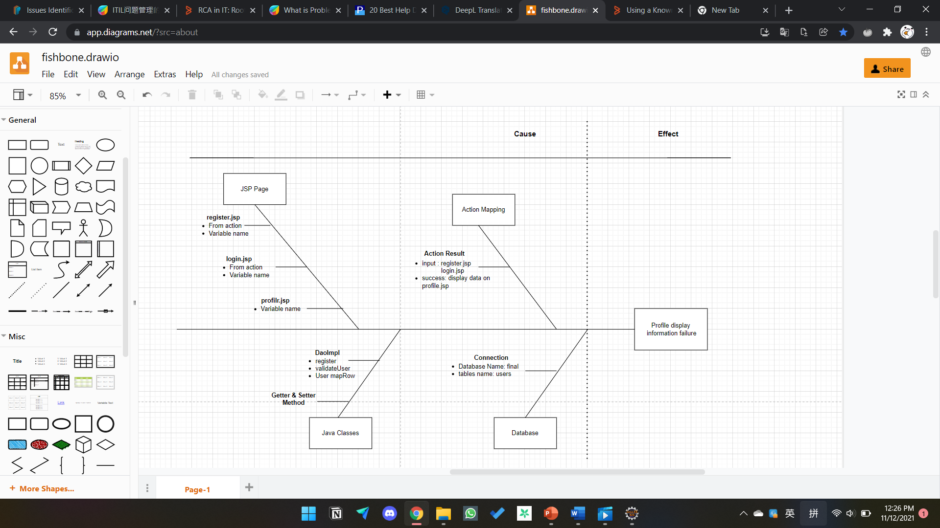

# Project Requirements Specifications

## **3.1 Functional requirements**

**Users (Software Programmer)**

**Register:** New Software Programmers can create an account and register on the community portal.

**Login:** Software Programmers can log in to their accounts using their credentials

**Logout:** Software Programmers can log out of their accounts to end their session.

**Posting messages : Software Programmers should be able to post on their dashboard**

**Search users:** The Software programmer can search for other users by parameters like First Name, Last Name.

**Update profile:** Software Programmers can edit and update their profile information.

**Administrator**

**Login:** Administrators can access their accounts with their login information.

**Add user:** To end their session, administrators can log out of their accounts.

**Delete user: admin can delete user data that has registered on the portal.**

**Modify user:** The admin can update the data of users who have registered on the portal.

## **3.2 Non-functional requirements**

These are the requirements that don't deal directly with what the website does, but how it performs and the information it holds.

**Safety requirements**

**The database holds personal information of users,.**

**Performance attributes**

**Availability: The website should be accessible and working well most of the time.**

**Maintainability: The community portal is regularly monitored and maintained by the administrator.**

**Usability: The ABC community portal can include a large number of users and has a large capacity to store user information.**

# Task 1: Principles of Problem Management

## What is Problem Management?

Problem Management is a proactive process in IT service management that aims to identify, investigate, analyze and resolve the root causes of incidents and problems. The focus is on addressing the root causes of recurring issues, minimizing their impact on services, and preventing similar occurrences in the future.

## 4.2 The Three Phases of Problem Management

1. Problem Identification

This phase signifies the early recognition of potential issues that may affect IT services. This involves leveraging sources such as incident reports, trend analysis and user feedback to proactively identify potential problems and prevent their escalation.

**Incident Reports:** Monitoring and analyzing incident reports helps in identifying recurring patterns or issues that may indicate an underlying problem.

**Trend Analysis:** Examining historical data and trends can reveal anomalies or deviations that can lead to potential problems.

**User Feedback:** Gathering feedback from users can provide insight into their experience, uncovering issues before they become a major concern.

1. Problem Control

Immediate steps are taken at this stage to temporarily reduce the impact of the known problem or prevent its damage. Quick solutions are implemented, such as isolating the problematic component or implementing temporary fixes, until a permanent solution is established.

* **Component Isolation:** If a particular component is causing problems, isolating it can prevent its negative impact from spreading to other parts of the system.
* **Temporary Fix:** Implementing a workaround or workaround can quickly restore functionality while a more permanent resolution is being developed.
* **Service Continuity:** The focus is on maintaining service availability and functionality while minimizing disruption caused by issues.

1. Error Control

Effective problem management also includes managing errors in their workflows. Proper tracking, reporting, and correction of errors that occur during the problem management process is critical to ensuring process integrity.

* **Error Tracking:** Logging errors and problems encountered during problem management allows for a systematic understanding of where problems may occur in the process.
* **Error Reporting:** Transparently communicating errors to the relevant team ensures that issues are recognized and can be dealt with efficiently.
* **Error Correction:** Correcting errors in a timely manner prevents them from spreading further and maintains the accuracy and reliability of the entire problem management process.

## 4.3 Principles of Problem Management

1. Problem Identification

* **Sources of Identification:** Problem identification can come from user reporting, system monitoring, and analysis of operational data.
* **Initial Categorization:** The identified problems are given an initial category based on their type or impact, assisting in the shifting of treatment priorities.

1. Problem Investigation

High priority or high-risk problems should be resolved first, as their impact on the service is highest. The speed at which problems are investigated and diagnosed depends on the priority assigned. Correctly categorising problems makes it easier to identify trends.

* **Investigation Priority:** Issues with high impact or high risk receive higher priority in the investigation process.
* **Data Analysis:** Incident data and other information is analyzed to identify patterns or trends that can assist in investigations.
* **Source Identification:** The main aim of an investigation is to identify the underlying source of the problem.

1. Problem Analysis

* **RCA (Root Cause Analysis):** Involves an in-depth analysis method to identify the root cause of the problem, not just the surface symptoms.
* **Recovery Measures:** Based on the analysis, more effective and permanent recovery measures are planned.

1. Problem Resolution

* **Solution Development:** The problem team designs a solution that focuses on addressing the root cause of the problem.
* **Change Deployment:** The change is implemented, and the service is returned to its normal state with the new solution being implemented.

1. Review

* **Effectiveness Evaluation:** Evaluation is conducted to ensure that the implemented solution actually addresses the problem.
* **Lessons Learned:** Lessons from this issue are documented to improve the problem management process in the future.

## 4.4 Problem Management Example

Identification problem:

1. User Profile Data Issues:

* Description: Users were unable to view their profile data while logged in.
* Impact: User experience is impaired, potentially affecting service satisfaction.

1. Error Viewing Invalid Credentials:

* Description: An error was not displayed when the user entered incorrect login credentials.
* Impact: The user may not understand why the login attempt failed.

Problem Identification:

1.The user is logged in and when viewing their profile, the user data is not displayed.

2. Unable to view errors on invalid user id and password.

Screenshot of client-side screen

User Login:



User profile page:

# Task 2: Tools, Process & Technologies

## Problem Logging

Techniques = Issue Tracking System

Tool = Excel Sheet

Using an Excel sheet to make a tracking document template is an important tool for issue identification.

Process:

* 1. receive an email
  2. Verify.
  3. Create or
  4. Repairing the
  5. When the issue is fully resolved, it will be marked as resolved in the issue tracking system.

|  |  |  |  |  |  |  |  |  |  |  |
| --- | --- | --- | --- | --- | --- | --- | --- | --- | --- | --- |
| Issue Identification and Tracking Document | | | | | | | | | | |
| Created By: | | |  | | Last Update By: | | |  | | |
| Date Created: | | |  | | Last Revision Date: | | |  | | |
| Issue No. | Issue Description | Issue Type | Identified By | Date Identified | Issue Assigned To | Target Resolution Date | Priority | Status | Date Resolved | Resolution Description |
| 1 | The registration form is not connected to the database | Technical Issues | Software Tester Team |  | Software Development  Team | 8. | High | Resolved |  | Correcting code for DAO linked databases |
| 2 | Invalid login details error not displayed | Technical Issue | Customer | 7-8-2023 | Software Development  Team | 8-8-2024 | Medium | Resolved | 8-8-2023 | Error messages code attached |
|  |  |  |  |  |  |  |  |  |  |  |
|  |  |  |  |  |  |  |  |  |  |  |

1. **Problem Investigation**

Techniques = Root Cause Analysis

Tool = Fish Bone

Process:

1. Clearly define the problem statement.

2.

1. Problem Resolution

Techniques = Known Error Database

Tool = Excel Sheet

Process

# Task 3: Investigate & Diagnose

1. **Task 3: Investigate & Diagnose**

**Investigation:**

* The speed at which a problem is investigated and diagnosed depends on its assigned priority.
* High-priority issues should always be addressed first, as their impact on services is the greatest.
* Correct categorization helps here, since identifying trends is easier when problem categories correlate to incident categories.

**Diagnosis Involves:**

* Analyzing the incidents that lead to the problem report
* Further testing that may not be possible at the service desk level, such as advanced log analysis

**Diagnosing the root cause of the problem through debugging and Add a breakpoint to the controller of the profile.**

use login function to test, use Add Breakpoint and check if debugging is going well.

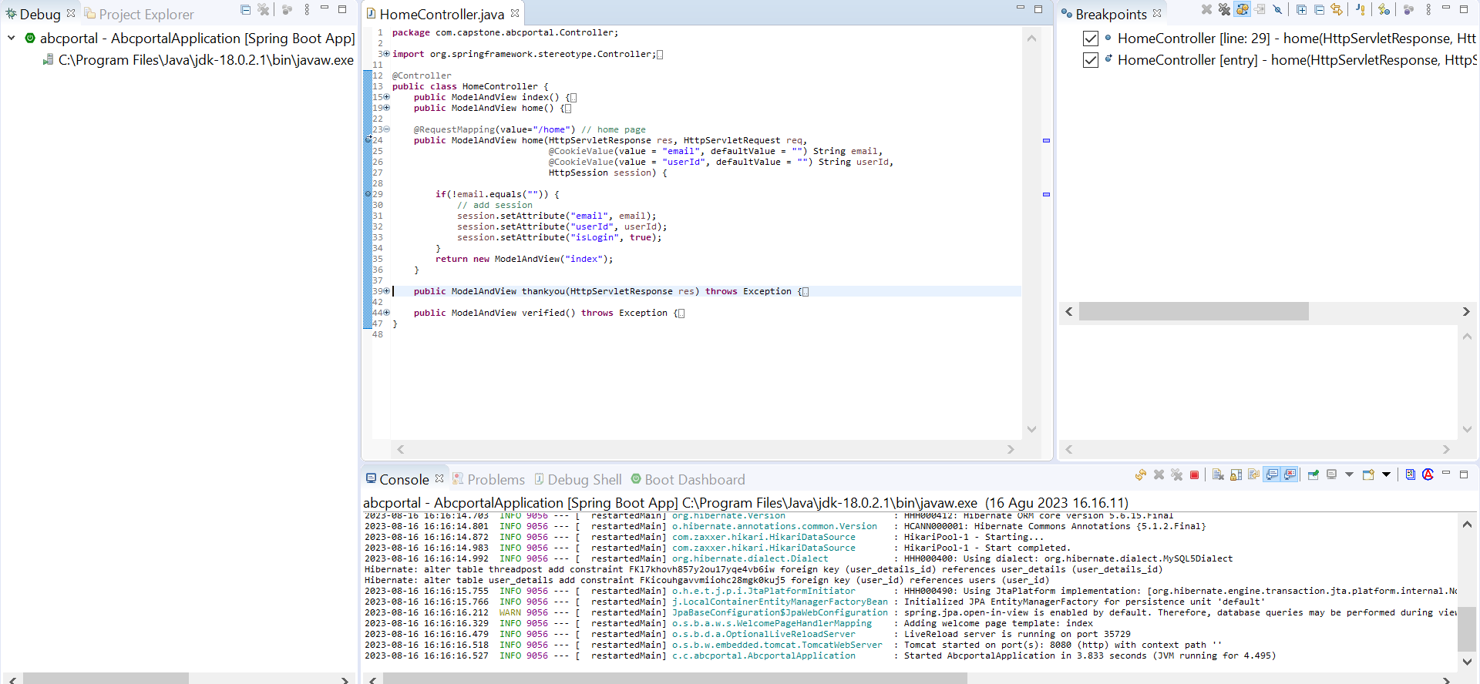

# Task 4: Explain Prioritize

Prioritization is the practice of grouping jobs, problems, or issues according to their priority or urgency. It assists teams in effectively allocating resources, time, and effort to tackle the most important issues first. Prioritization entails assessing the effects and repercussions of various problems to guarantee that the most pressing concerns are dealt with as soon as possible.

**Priorities and categories problems:**

**Tier 1: Low priority issues**

Description: Tier 1 comprises low-priority issues that have minimal impact on the business or users.

Characteristics: These are basic issues that do not disrupt operations and can be worked around until resolved.

Examples: Basic computer troubleshooting, minor software glitches.

Resolution: Tier 1 incidents are often easy to solve and recur frequently. They may be turned into incident models to streamline resolution.

Response Time: These incidents have a lower response time compared to higher tiers

**Tier 2:** **medium priority issues**

Description: Tier 2 includes issues that have a moderate impact on users but do not significantly affect the entire business.

Characteristics: These incidents require more skill or access to resolve

compared to Tier 1.

Examples: Software errors affecting specific functionalities, medium-level disruptions.

Resolution: Tier 2 incidents require a more immediate response and

higher level of expertise.

Response Time: Response time for Tier 2 incidents is faster than

Tier 1 but slower than Tier 3.

**Tier 3:** **High Priority Issues**

Description: Tier 3 encompasses critical problems that affect the entire organization and may cause significant disruption to the business.

Characteristics: These incidents require immediate attention and often fall into the Major Incident Response (MIR) process.

Examples: Downtime of critical systems, widespread service outages.

Resolution: Tier 3 incidents demand swift and comprehensive resolution due to their high impact.

Response Time: These incidents have the highest response time, and their resolution often involves specialized teams.

**Problems Categories Diagram:**

# Task 5: Problem Management Solution

Solution

Case problem:

1. User threads are not being displayed properly after creating a post thread.
2. Messages are not being sent to users as intended.

Solution:

1. Check controller and service method which is responsible for fetching post thread data from database and sending message to user.
2. Identify and fix any errors in relevant functions/methods related to fetching post threads and sending messages.
3. Thoroughly test the merge function to ensure that user threads display correctly after posting and messages are sent successfully.
4. Once the problem has been resolved, record it in the KEDB table to prevent it from recurring.

|  |  |  |  |  |  |  |
| --- | --- | --- | --- | --- | --- | --- |
| Known Error Database | | | | | | |
| **Ticket no.** | Issue Description | Issue Type | Root Cause | Workaround | Status | Date Resolve |
| 1. | The registration form is not connected to the database | Technical Issues | There is missing DAO code to connect to the database | Correcting code for DAO linked databases | Resolved |  |
| 2 | Invalid user information not display | Technical Issues | Error code was not attached for display error | Added the code in the login page | Resolved | 8.8.2023 |

1. Task 6: Systems will be implemented



# Task 7: Best Practices in Problem Management

Navigating problem management with adherence to best practices and industry standards is crucial for maintaining operational efficiency and delivering exceptional service. Here are five fundamental best practices to guide effective problem management:

1. **Clear Separation of Clients and Incident Handlers:** To enforce a transparent and impartial problem-resolution process, it is important to establish a clear separation between the client and the individual responsible for handling incidents. Ensuring that the incident handlers are distinct from the affected clients prevents potential conflicts of interest. This separation facilitates objective analysis, effective communication, and the unbiased pursuit of solutions. It is a cornerstone practice that fosters trust and assures clients that their concerns are addressed professionally and objectively.
2. **Establishment of a Known Errors Database:** A robust Known Errors database is pivotal for informed decision-making and continuous improvement. Every resolved incident should be meticulously documented in this database. Doing so creates a repository of historical incidents and their solutions, which becomes a valuable resource for future troubleshooting. The Known Errors database accelerates the resolution of recurring issues and supports proactive problem management. Patterns and trends identified from this database can drive preventive measures and systemic enhancements, minimizing the impact of potential problems.
3. **Root Cause Analysis and Resolution:** Addressing the symptoms of a problem is important, but it is equally crucial to identify and resolve the root cause. Conduct thorough root cause analysis to understand the underlying factors contributing to incidents. Targeting the root cause prevents the recurrence of similar issues and lays the groundwork for sustainable solutions. This practice improves service quality and demonstrates a commitment to delivering lasting results.
4. **Continuous Communication and Feedback Loop:** Effective problem management involves consistent communication with clients and stakeholders. Maintain an open feedback loop to keep clients informed about the status of incident resolution and any preventive measures being implemented. This transparent communication instills confidence in your problem-management process and shows clients their concerns are being taken seriously. Furthermore, client feedback provides invaluable insights for refining problem-management strategies and enhancing service delivery.
5. **Regular Review and Improvement:** Problem management is a dynamic process that requires continuous evaluation and improvement. Regularly review the efficiency of your problem management practices, analyzing metrics such as incident resolution time and client satisfaction. Use these insights to identify areas for enhancement, refine processes, and implement corrective actions as necessary. A culture of continuous improvement ensures that problem management remains adaptive and responsive to evolving challenges.

By embracing these best practices, organizations can elevate their problem-management capabilities, enhance customer satisfaction, and cultivate a resilience and proactive problem-solving culture.

https://techqualitypedia.com/fishbone-diagram-ishikawa-diagram/